**Spring 2022: Mobile Application Development**

**Assignment 4 - UCC IT Club App**

**Juneika Canegan - 20181125**

**Namoy Roberts - 20202942**

**Omary Lawrence - 20183072**

Please see the below screenshots of my UCC IT Club app:

**VIEW ONE:** Landing page of the app. You will be given a menu to select from, where you view the admissions information, course information, staff directory and timetable.

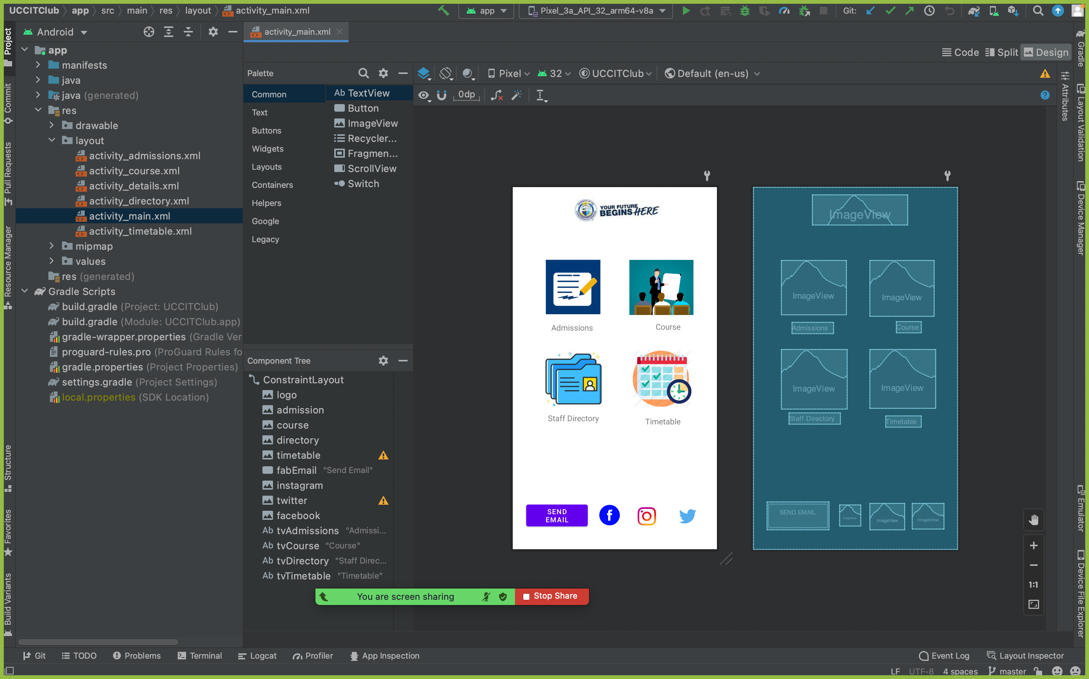

**VIEW TWO:** Once you click on the admissions icon, you will be presented with the below page.

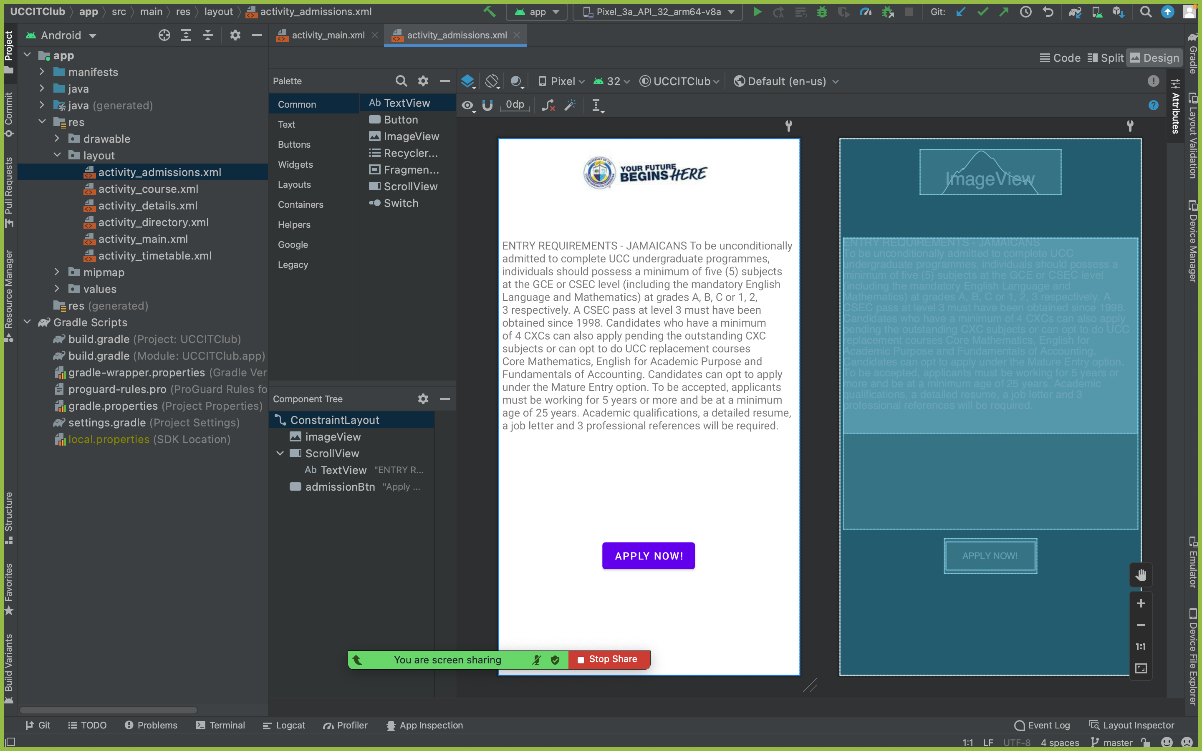

**VIEW THREE:** Once you click on the courses icon, you will then be presented with the below page.

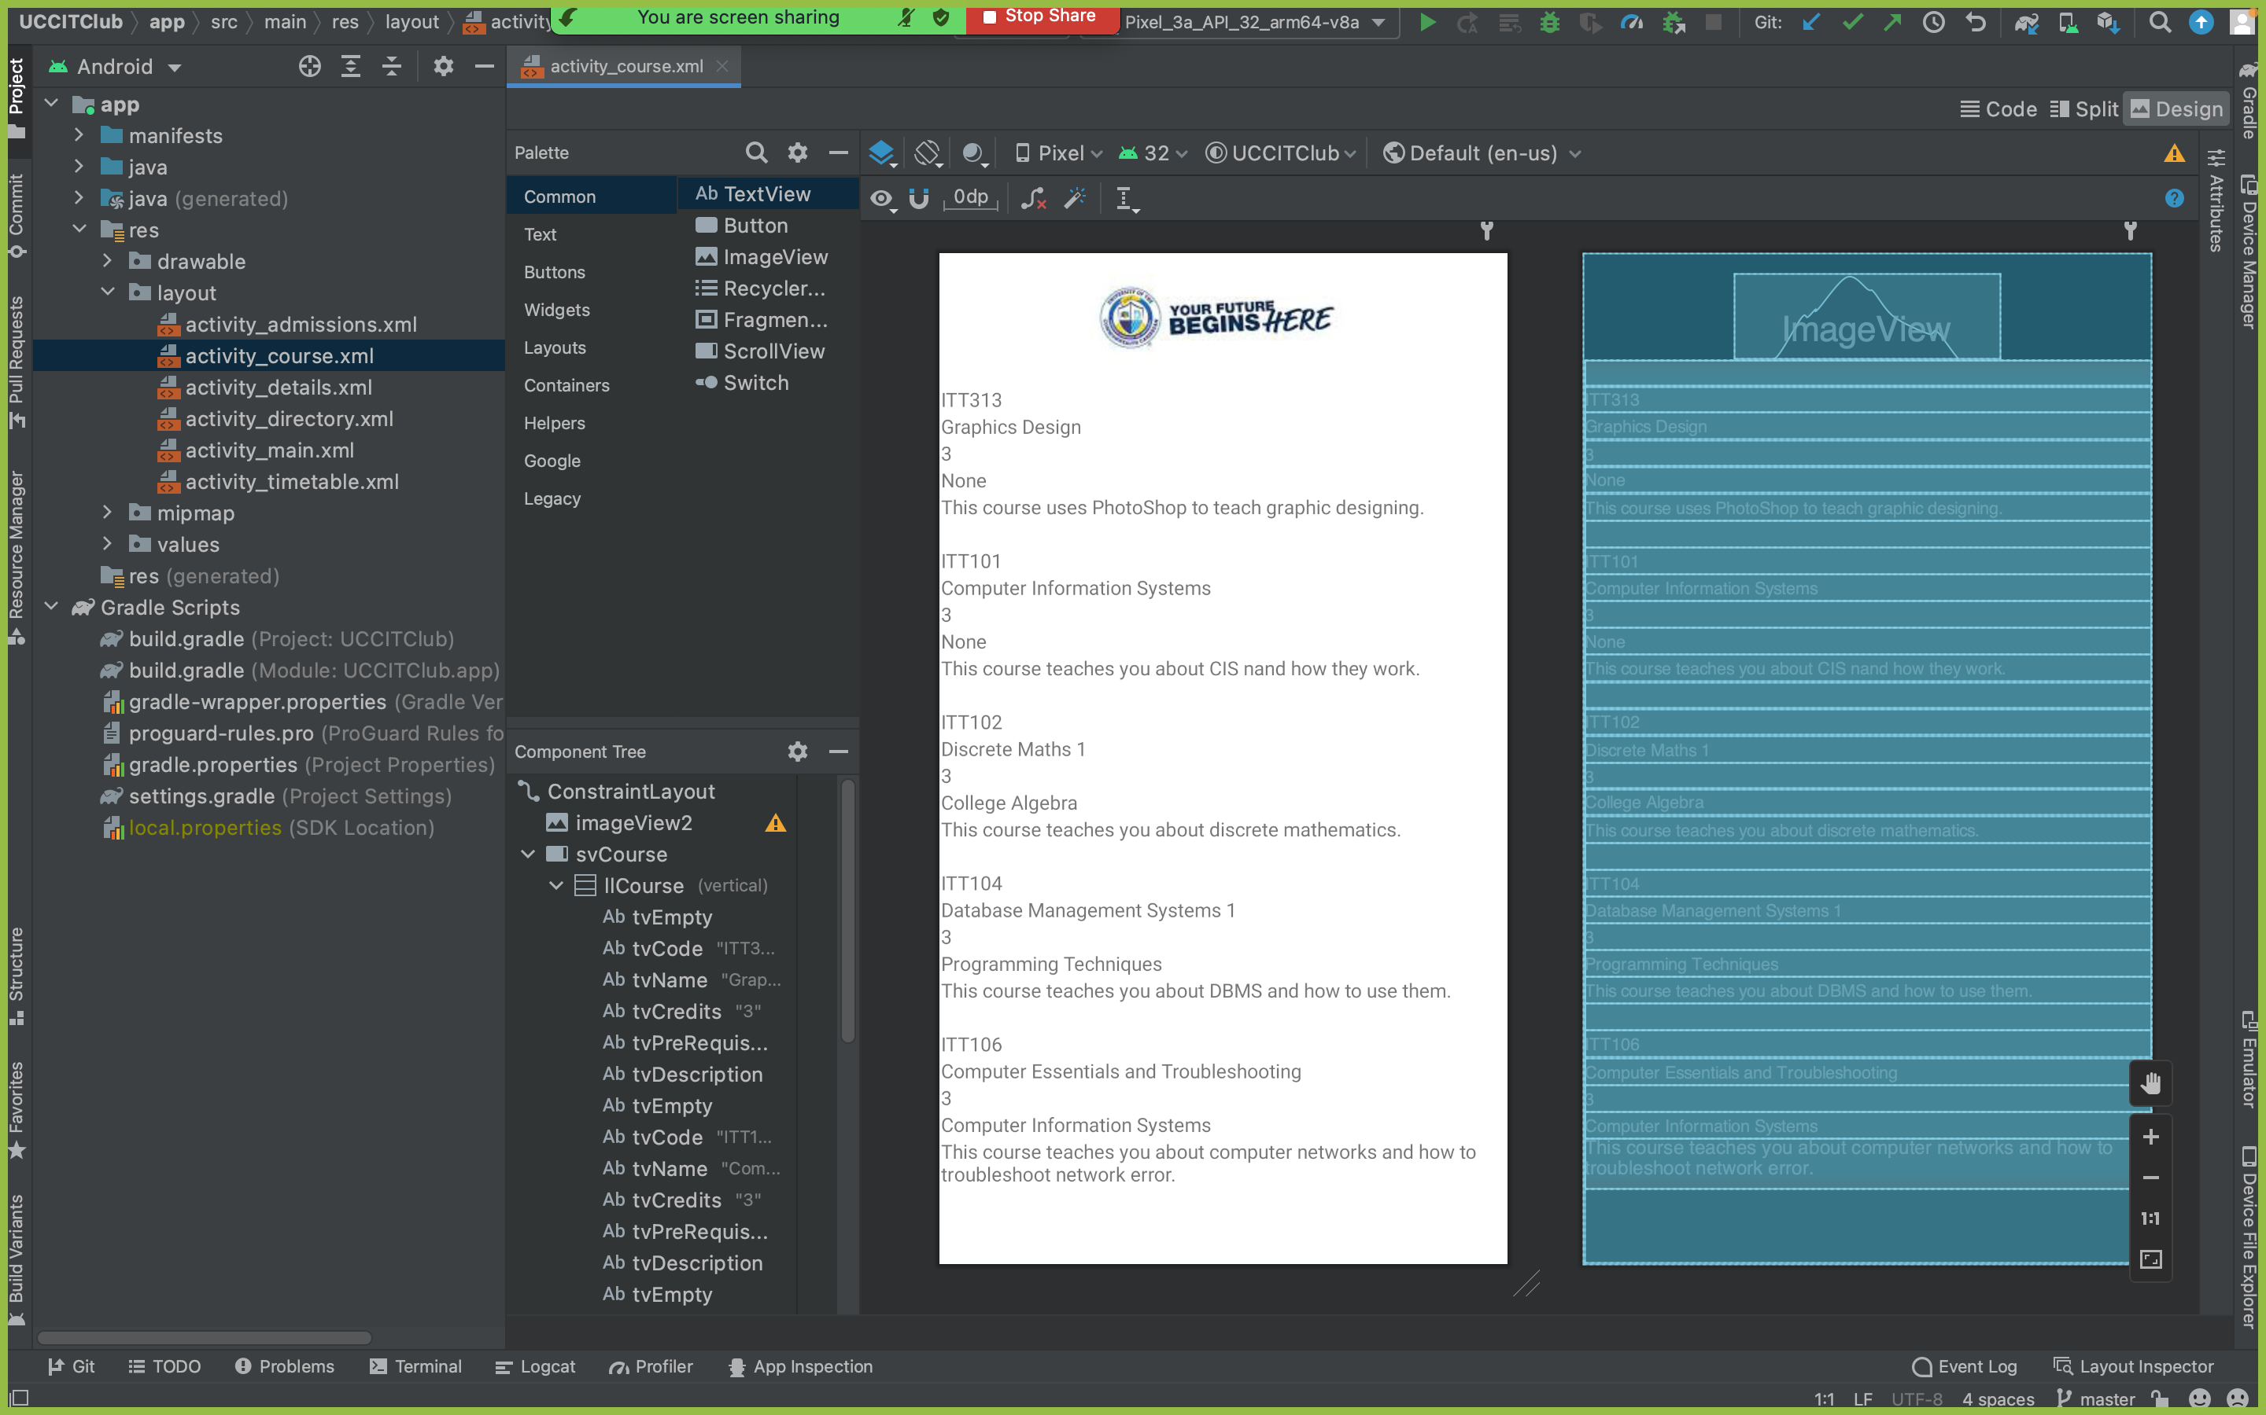

**VIEW FOUR:** Once you click on the timetable page, you will then be presented with the below.

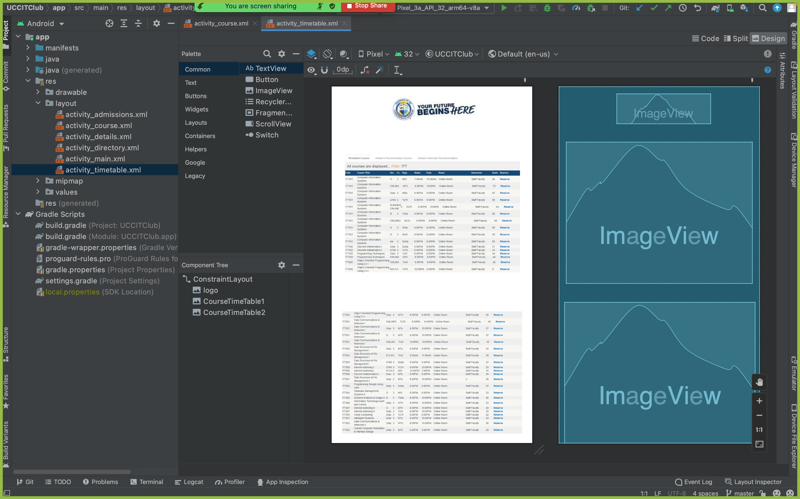

**VIEW FIVE:** Once you click on the email button on the main menu or landing page, you will then be taken to the page below.

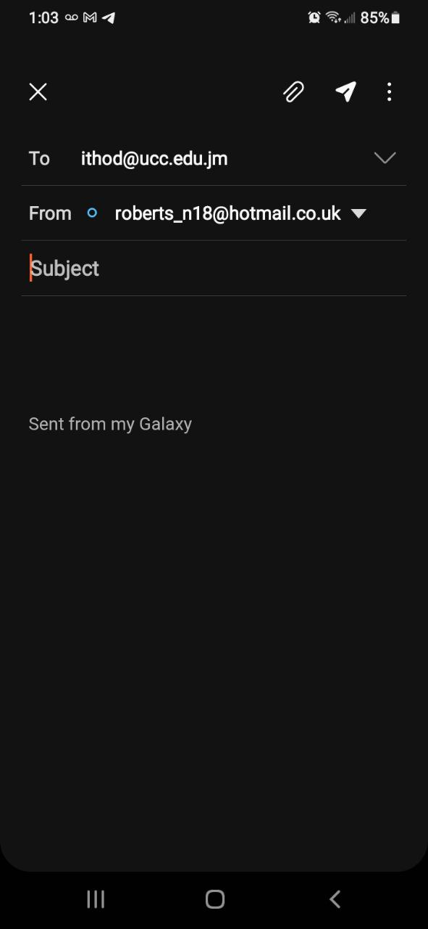

**VIEW FIVE:** Once you click on the Facebook icon on the main menu or landing page, you will then be taken to the page below.

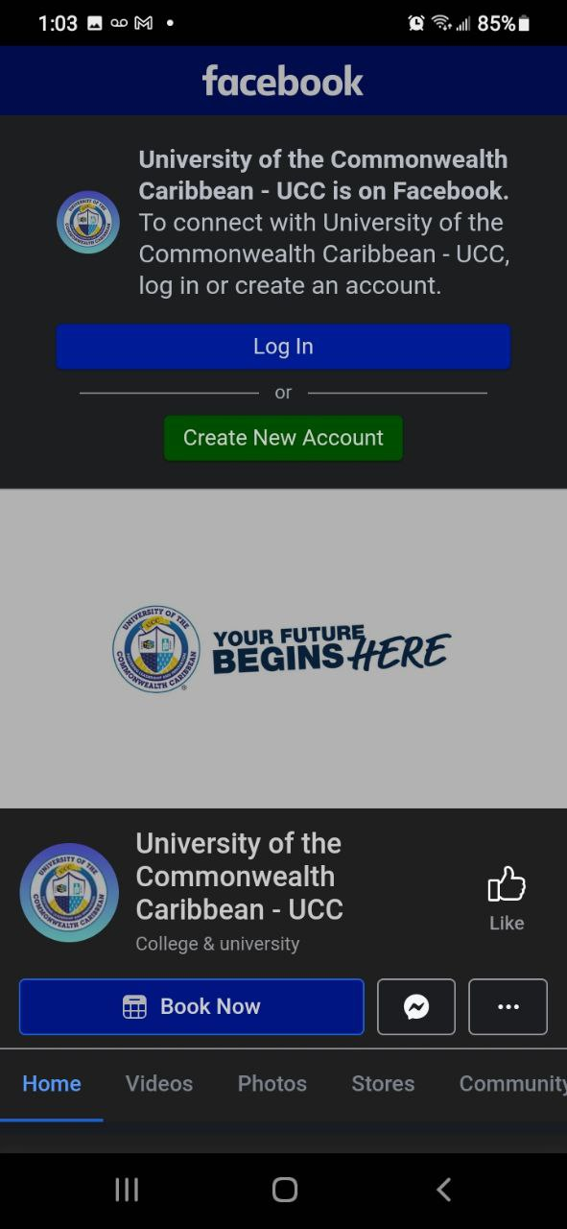

**VIEW SIX:** Once you click on the Instagram icon on the main menu or landing page, you will then be taken to the page below.

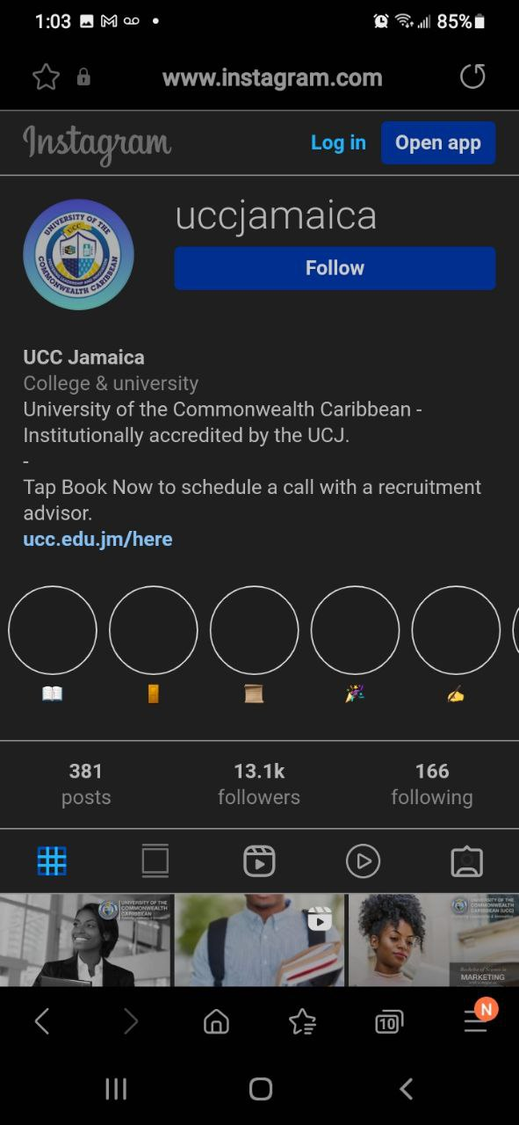

**VIEW SEVEN:** Once you click on the Twitter icon on the main menu or landing page, you will then be taken to the page below.

